EXPERIMENT 1

Program A: 8-bit Addition & Subtraction

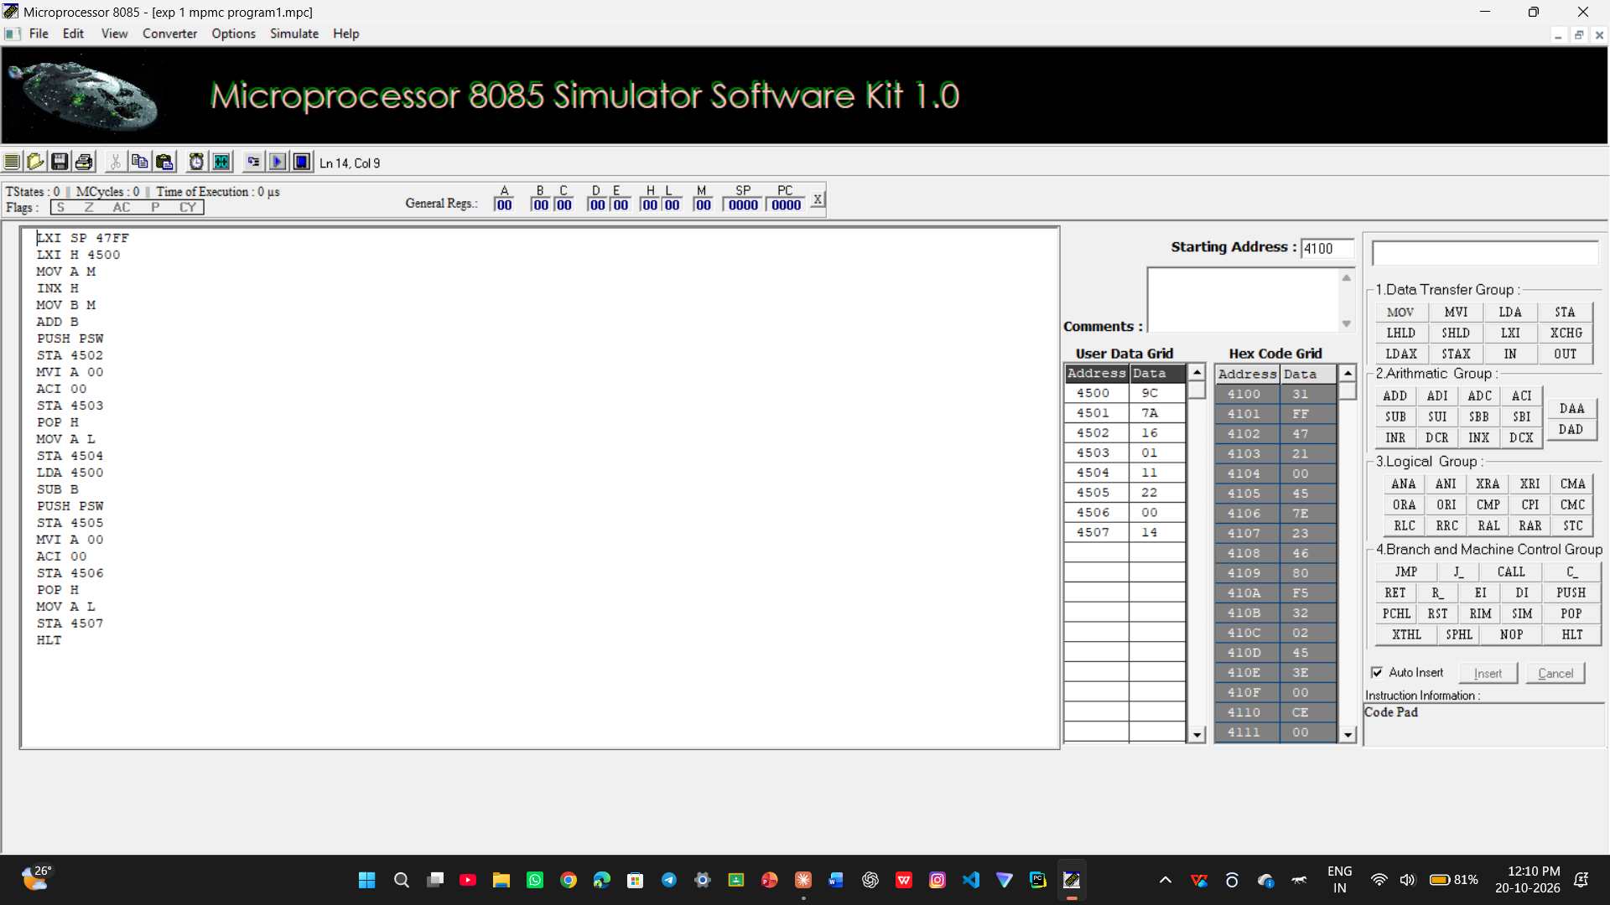

Program B: 16-bit Addition & Subtraction

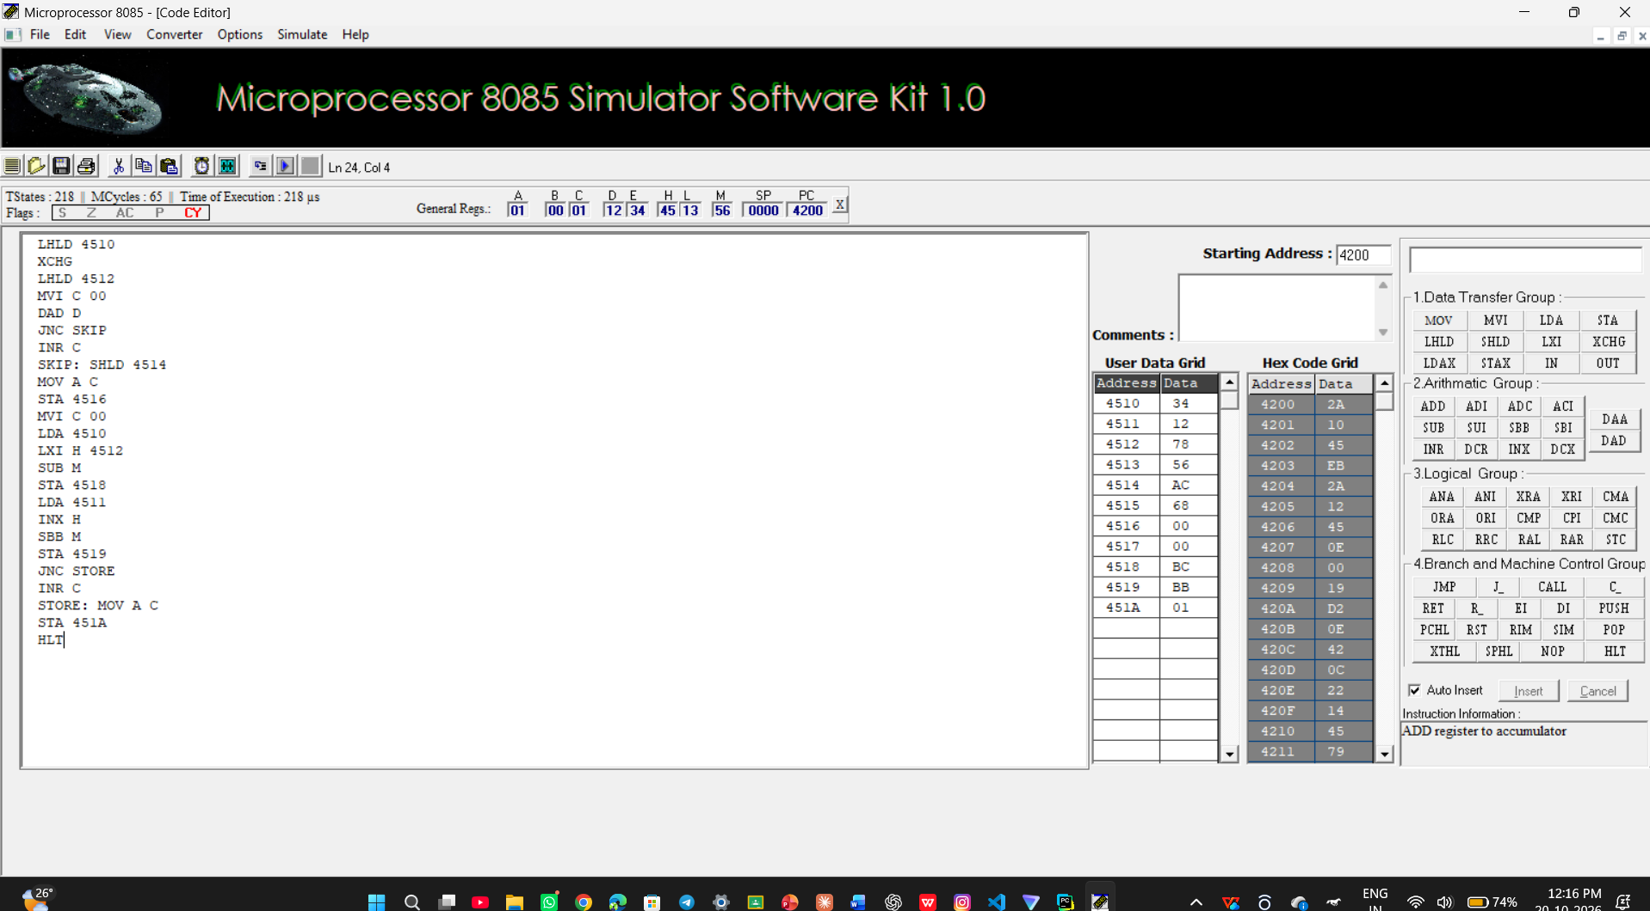

Program C: 8-bit Multiplication & Division

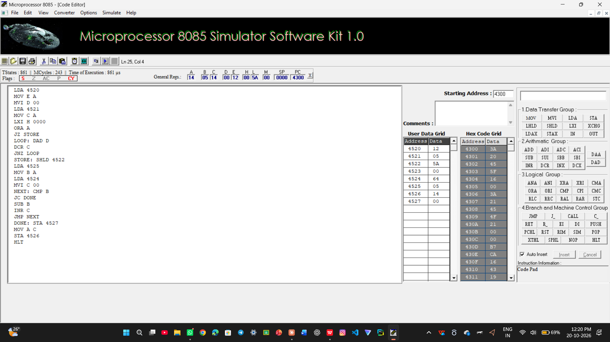

Program D: 16-bit Multiplication & Division

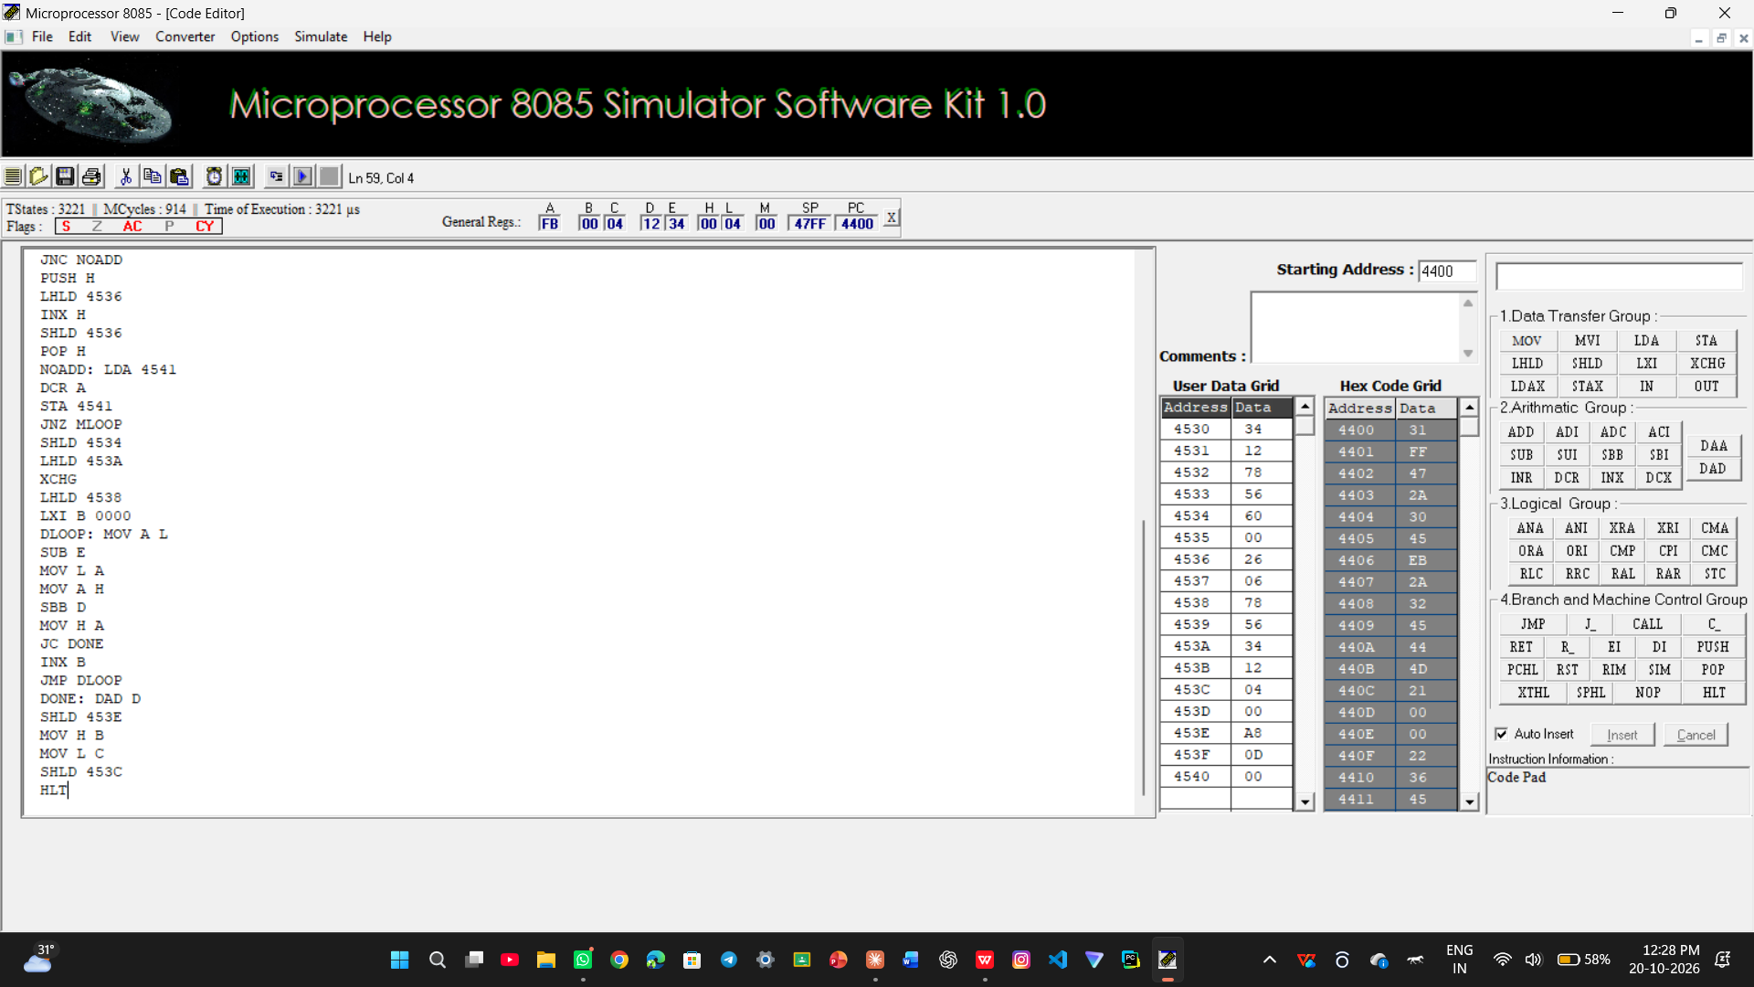

Task 1: 8-bit & 16-bit Addition and Subtraction (Set 2)
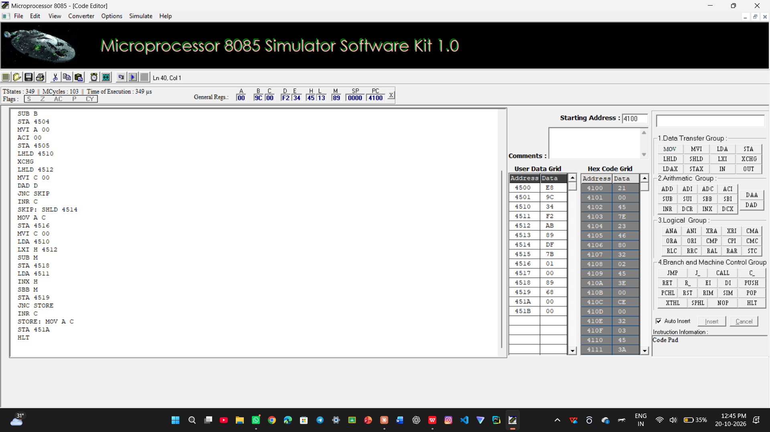
Task 4: Division by Zero Check

